Ideation Phase
Define the Problem Statements

Date | 31 January 2025
Team ID | LTVIP2026TMIDS76805
Project Name | Online Payments Fraud Detection using Machine Learning
Maximum Marks | 2 Marks

Customer Problem Statement Template:
A well-defined customer problem statement helps us understand the real challenges faced by users and businesses in online payment systems. It allows us to empathize with customers and design an effective fraud detection solution..
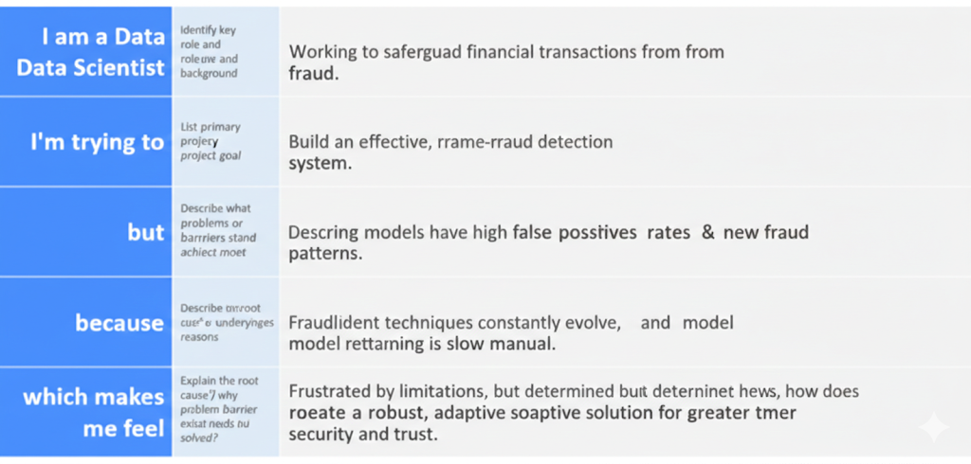

Example:
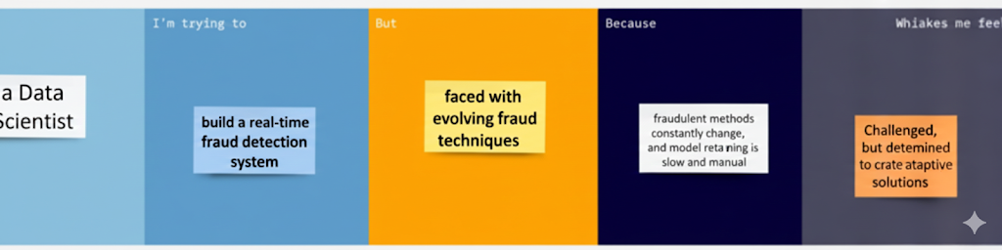

Problem Statement (PS) | I am (Customer) | I’m trying to | But | Because | Which makes me feel
PS-1 | I am an online payment user | I’m trying to make secure digital transactions | But I am worried about fraud and unauthorized transactions | Because cybercriminals can misuse my account details | Which makes me feel unsafe and anxious while making payments
PS-2 | I am a bank / fintech company owner | I’m trying to protect customers and reduce financial losses | I’m trying to protect customers and reduce financial losses | Because fraud patterns are complex and continuously changing | Which makes me feel concerned about security risks and business losses

